Comments on inside portraits

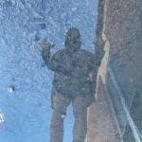

I mess wit this picture because of the reflection is dope and 1400, 1800 gang goes hard and dripped out no skips around here gang.

I like this picture because the lighting is good and the object floating looks good.

I like this picture because jack is biting the table and yeah nice pic.

This picture goes hard it’s a nice close up picture with the green in the background nice pic.

